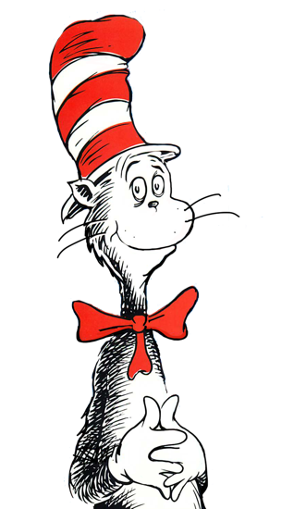

**Wish List**

Red cardstock Green cardstock

White cardstock Blue cardstock

Brown cardstock Red, green & clear pinwheel beads

Small foam stockings (24) Small foam pine trees (24) Glitter glue Pipe cleaners

Plus more…

* If you are able to donate any supplies, please go to the following site to sign up.

[www.SignUpGenius.com/go/5080F4DA9A62FAB9-holiday](http://www.signupgenius.com/go/5080F4DA9A62FAB9-holiday)

**Rapid Reminders**

**Nov. 24th &25th:** No school for Thanksgiving break

**Dec. 2nd:** Early Release Day at 1:15 with lunch at 12:30

**Dec. 16th:** Holiday Celebration at 12:00

**Dec. 21st:** Track out day

**News Now…**

**Literacy:**

This week the children worked very hard using the Eagle Eye strategy to help them figure out new words in texts. They also worked on creating –at family words and reading color words to illustrate books accurately. In writing, the children worked to create a list of things they are thankful to have.

**Math:**

During math, the children began working with teen numbers. They practiced counting sets using various strategies to keep track of objects. They also worked on writing teen numbers being careful to put the digits in the correct place i.e. 13 versus 31.

**Letterland:**

We have revisited several Letterlanders. The children worked with Mr. O the Old Man, Peter Puppy, and Eddy Elephant. They also practiced stretching words and shaking out sounds to write them. Please ask your child how we do this.

**What’s to Come…**

**Boosterthon**

We had 2 great Boosterthon weeks! Thank you all so much for your

support getting pledges and during the Fun Run! Our classroom is

going to receive 10% of the amount we collect by the first collection

day. I hope to use these funds to purchase some flexible seating

options, more leveled books, and miscellaneaous classroom supplies and

planning materials. Thank you all, again for your help!

**Literacy Night**

Thank you so much to everyone who came out for our Literacy Night. It was great to see you and share some of the things we do in the classroom to help our children become readers.

**Thanksgiving**

School will be closed next Thrusday and Friday (11/24 & 11/25) so that we can all celebrate the Thanksgiving holiday. Please have a great weekend and if you plan to travel be safe! We will only have one activity for homework next week. I am sending a paper turkey home for you and your child to disguise. We read Turkey Trouble this week. In the story the turkey was trying to disguise himself like other animals so that he would not be eaten on Thanksgiving. I would like the children to disguise their turkeys to keep them safe on the holiday.

**Holiday Celebration**

I know this is early, but I wanted to send out the date we have planned our Holiday Celebration. We are planning for December 16th at 12:00. You will receive more information as the date approaches. I will also be including a wish list in this newsletter to collect supplies for our holiday experiences.

**The Weekly Word**

11/18/16